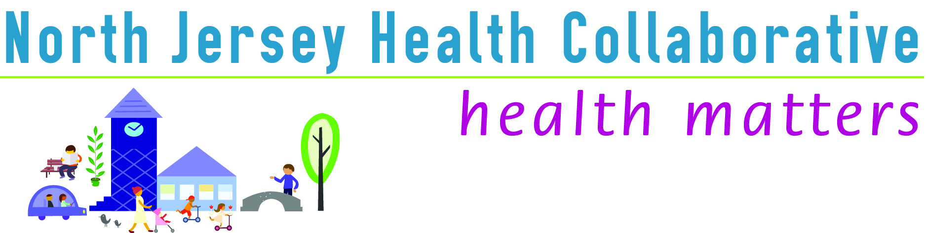

County Committee: Warren (WC Community Health Improvement Coalition)
Date: 1/27/17
Location: Warren County Community College
Time: 10:00am

Number of attendees: 22

AGENDA | PRESENTER | DISCUSSION | ACTION/FOLLOW-UP/RESPONSIBLE PARTY
Call to Order/Introductions | S. Perramant | Ms. Perramant called the meeting to order. See sign-in sheet for list of attendees.
Review of Minutes | S. Perramant | October meeting minutes were presented. Accepted by group.
Introductions & County News | S. Johnson-Hakim  P. Summers | • Ms. Johnson-Hakim gave an overview of the NJHC Needs Assessment 3 | S. Perramant will send survey for workgroup participation/development of new workgroups
Introductions & County News |  | • Old needs assessments were repetitive/resource intensive. Working on fully integrating additional coalitions/partners for more data collection in next needs assessment.
Introductions & County News |  | • Warren data is now on northjerseyhealthmatters.org. Plans on website do not currently include Warren.
Introductions & County News |  | • Community Dashboard Data tab pulls relevant publicly available health data from around the web and shows them in an easy-to-read format. Indicators are compared to the nation and to NJ. Also shows prior value and map of neighboring counties. Some data points are available by zip-code level.
Introductions & County News |  | • First needs assessment – data committee looked at ALL data available for the website. Made a list of top issues and then sought community input to narrow down issues. Data committee ranked data versus the stakeholder input and narrowed down to 8-10 issues per county. Then took these issues and “dug deeper”
Introductions & County News |  | • Prioritized areas are leverage for overall goals. Each area has strategies identified by workgroups - some are collecting more data and some are moving forward with action items… hoping to refine data collection for better impact.
Introductions & County News |  | • Warren County Workgroups – NJHC Committees include all of the counties plus the two regional committees. Each committee has issue-driven workgroups. ID workgroups in Warren and determine gaps (Coalition for Healthy & Safe Communities, Sussex-Warren Chronic Disease Coalition, Nutrition Workgroup, Access to Care group needed?)
NJHC Presentation | C. Connelly | • Ms. Connelly screened the NJHC video. | C. Connelly can send “sign up” form for adding organization info to njhealthmatter.org
NJHC Presentation | C. Connelly | • NJHC Mission: Building capacity to improve community health. (Warren, Sussex, Morris, Passaic, Union counties). Priorities overlap, but there are specific ones based on specific county needs. Organization chart (25-member board of trustees; chair and chair elect for each county committee.)
NJHC Presentation | C. Connelly | • New NJHC executive committee: President: Arlene Stoller, VP: Kiran Gaudiso, Treasurer: Pete Correale, Secretary: Ashley Anglin, Data Chair: Sharon Johnson-Hakin, Marketing Chair: )
NJHC Presentation | C. Connelly | • Data committee = 4th Tuesday of the month
NJHC Presentation | C. Connelly | • Add resources to partner resource directory for sharing info about your organization.
Election of Chair & Vice Chair | S. Perramant | • Mr. Summers (Warren County Health Officer) volunteered to be the chair.
Election of Chair & Vice Chair | S. Perramant | • MaryJo Harris (Family Guidance Center of Warren County) volunteered for vice chair.
Election of Chair & Vice Chair | S. Perramant | • Nominations accepted by the group.
Meeting Close

Note Taker: Sarah Perramant Next Meeting: April 28th, 9am, WCCC 475 NJ-57, Washington, NJ 07882

