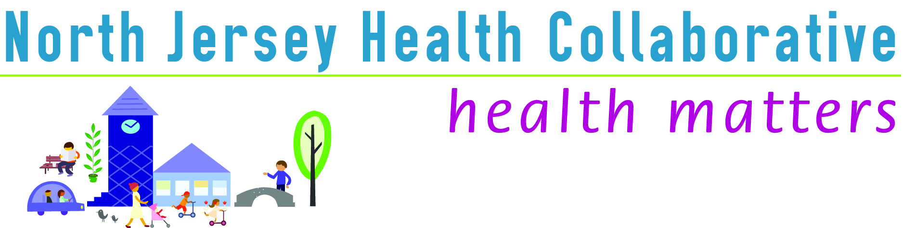

County Committee: Morris County

Date: Thursday, April 13, 2017

Location: Morris County Public Safety Training Academy

Time: 10:00am – 12:00pm

Number of attendees: 32
See sign-in sheet for contact information/listing.

AGENDA | PRESENTER | DISCUSSION | ACTION/FOLLOW-UP/RESPONSIBLE PARTY
Call to Order | Kathy Skrobala,  Chair Morris County | At 10:10am Kathy introduced herself and welcomed all to the meeting.
Review of Minutes | No minutes reviewed.
Introductions & County News | Kathy Skrobala | Everyone introduced themselves and their organization.

AGENDA | PRESENTER | DISCUSSION | ACTION/FOLLOW-UP/RESPONSIBLE PARTY
NJHC Collaborative News | Catherine Connelly, NJHC | NJHC “Moving Forward Together” is at 98% of its funding partner target. The results of the Professional Development Brainstorming sessions were given. Catherine thanked all of the workgroup leads and membership for their time and effort. | Upcoming webinars and program  4/27/17 – “Lets Write a Grant” – Denise Lanza, Morris County Park Commission  5/23/17 – “Collective Impact in the Real World: From Community Collaboration Evaluation – Ashely Anglin, PhD  6/29/17 – Tentative date - “Public Health 3.0” an all partner meeting  Register details at NJHealthMatters.org
County Health Improvement Plan: Progress and Q & A | Sharon Johnson-Hakim, PhD | ACPHS gave a brief overview of the Community Health Improvement Plan, workgroup template form and facilitated “Performance Measure Reports” given by workgroup leads or members:  Obesity, Diabetes/Cardiovascular, Behavioral Health, Heroin, Morristown United for Healthy Living Coalition | Workgroups will give “Performance Measure” updates at each quarterly meeting.
Wellness Activity | Maya Lordo, CHES | Yoga at your desk.
County News & Networking | Maryann Walsh | Maryann invited attendees to share upcoming programs from their organization with the group. | Caroline Schenkman -Free HIV Counseling and Referral Center at 200 South St, Suite 342, Morristown; KJ Feury - Honeywell Corporation, Safe Kids Day 5 K Run 4/30 in Morris Plains; Rich Cooke, Morris Habitat has funds for “Aging in Place”; Carlos Caprioli - voucher program and 4/22 Morristown Clean-up Day
Meeting Close | Kathy Skrobala | Kathy thanked everyone for attending the meeting. | Next meeting 7/13/17.
Workgroup Breakout Session | Kathy Skrobala | Attendees given the opportunity to meet with their workgroups.

Note Taker: Maryann Walsh

Next Meeting: Thursday, July 13, 2017 10:00am – 12noon at the Morris County Public Safety Training Academy

