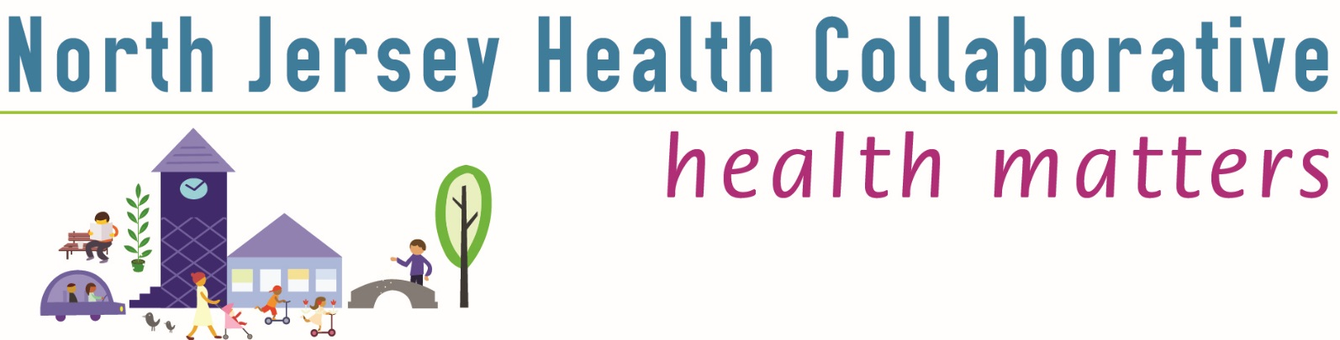

**County Committee: Morris County**

**Date: Thursday, Jan. 11, 2018**

**Location: Morris County Public Safety Training Academy**

**Time: 9 to 11 a.m.**

**Number of attendees**: **27**

|  |  |  |  |  |
| --- | --- | --- | --- | --- |
| **AGENDA** | **PRESENTER** | **DISCUSSION** | **ACTION/FOLLOW-UP/RESPONSIBLE PARTY** | |
| Welcome & Introductions | Maryann Walsh, Chair Morris County Committee | Maryann opened the meeting, welcoming the group to the first meeting of 2018. She recognized and thanked outgoing County Chair Kathy Skrobala, welcomed Chair-elect Diane Mann, and asked the group to introduce themselves, their organizations and NJHC Committees on which they serve. |  | |
| NJHC Collaborative News | Catherine Connelly, NJHC | * Catherine noted the accomplishments of Morris County Committee over the past year * She mentioned the “Moving Forward Together” campaign, shared the list of funding partners and said about $6,500 is needed to reach funding target for this year. * Professional development plans are underway need ideas, tools and other resources that can efficiently help advance the group’s development * She shared results of the partner survey Q4 and website survey from Q4 2017. Introduced Ashley Anglin to present the next phase of the CHNA and Community Voice Survey. | * Members are asked to consider becoming a funding partner * Please contact Catherine with professional development ideas and resources. | |
| Community Voice Survey | Ashley Anglin, PhD, coordinator at AHS Center for Population Health Sciences | * Ashley reviewed the final survey format, noting that the NJHC partners are seeking more direct community input for our Community Health Needs Assessment. * Among other items, the survey will explore gaps in access to health resources and health disparities by location and other demographics. * It includes open ended questions and opportunities to review results, join the Collaborative, and/or receive a prize. * Launched on Jan. 8, the survey (preview available at [www.njhealthmatters.org/tiles/datacommittee](http://www.njhealthmatters.org/tiles/datacommittee) under “tools and resources,” will be open until April 30, can be administered online, via mobile device and on paper. * Ashley reviewed distribution instructions, including maintaining data integrity and confidentiality. * The largest possible sample will yield the greatest possible trend and findings data, she said. | * Members were asked to take the survey as community members and to sign up their organization to administer the survey. Organizations can sign up at **goo.gl/ET7seG** * Survey distribution instructions should be followed to protect data integrity and confidentiality. * Surveys collected on paper should be directed to the Data Committee at [www.njhealthmatters.org](http://www.njhealthmatters.org) ; the Committee will enter the data. | |
| County Health Improvement Plan: Progress Reports and  Q & A | Committee & workgroup leads or members reported progress. | Obesity   * Denise Lanza & Arlene Stoller: preschool garden project is advancing. A conference to expand food access and reduce waste, in partnership with Interfaith Food Pantry, will gather various food service and social service groups, 10 a.m. Feb. 15.   Diabetes/Cardiovascular   * Catherine Connelly reported that the workgroup is making progress. The group is assessing existing resources and developing an inventory of resources. The Horizon Foundation grant CHW has been hired and has joined the workgroup. This funding will enable participants to be connected to primary care, diabetes education and social services.   Behavioral Health   * Christine Anderson reported on the ongoing stigma free campaign, Mental Health First Aid training, support services to clients of the Community Soup Kitchen, and the establishment of a new pediatric collaborative to establish relationships between pediatricians and mental/behavioral health providers. | * All reports are on the website: <http://www.njhealthmatters.org/> * Look under the Plans and Priorities Tab - Morris County Health Improvement Plan |
|  |  | Heroin   * Arlene Stoller reported on overdose increases in 2017, Narcan saves   and the positive impact of emergency room peer recovery coaches on access to treatment. A higher number are seeking recovery services. NJHC is the only agency collaborating on region-wide data gathering for heroin use. | * Need to further explore how to measure and report progress on metrics for Mental Health and Heroin in Morris County. |
|  |  | Morristown United for Healthy Living Coalition   * Ashley reported on trainings and services focused on census track 435, and evaluations showing positive change in residents’ perceived health status. |  |
| County News & Networking | Maryann Walsh | Maryann referred to the upcoming Collaborative and Committee meetings on the website. | * Committee members were asked to send resources and events to Catherine to have posted on the website calendar and resource library. |
| Workgroup Breakout Sessions | Group |  | * Considering the time, Maryann tabled the breakout sessions. |
| Closing: Next Meeting | Maryann Walsh |  | * Members were asked to attend the next meeting 9-11 a.m., Thursday, April 12, 2018 at the MC Public Safety Training Academy |

Note Taker: Diane Mann

**Next Meeting: Thursday, April 12, 2018 from 9 to 11 a.m., at Morris County Public Safety Training Academy.**