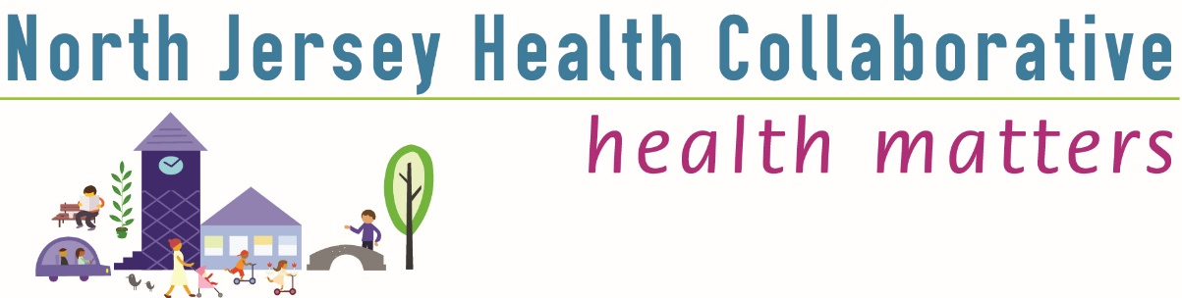

Union County Committee http://www.njhealthmatters.org/
Thursday, December 16th, 2021 3:00-3:35pm
Schedule:
Item | Presenter/Facilitator
Welcome & Call to Order | Paul Mickiewicz County Chair
Overview of finalized Community Health Needs Assessment and looking ahead to creating the Community Health Improvement Plan for the county and corresponding survey which will be shared with all partners. | Laura O’Reilly  NJHC Executive Director
Quick overview of cancer screening services for people with disabilities by ScreenNJ | Mary Ellen Zung NJHC Specialist
Opening for Union County Chair and Chair Elect/Paul’s retirement | Sheri Cognetti NJHC President
Adjournment | Paul Mickiewicz
Minutes of December 16, 2021 Union County Meeting

Welcome and Call to order. This was a special, short meeting for Union County so we dispensed with the self-introductions by all the group members.

*Paul welcomed all and shared that he will be retiring from the YMCA at the end of this year and that Laura will be looking for a new Union County Chair and also a Chair Elect. Laura invited anyone who may be interested about either position to contact her to receive more information

*Laura provided a quick look at the finalized version of the Union County Health Needs Assessment, (CHNA), and how the next step will be creating the Community Health Improvement Plan, (CHIP). To assist with this next step Laura shared a survey, https://www.surveymonkey.com/r/72GBX3N
to help inventory partner organizations programs and services in order to create action steps to address each the many varied needs identified in the CHNA.

*Mary Ellen Zung provided a quick overview of special cancer screening services provided by ScreenNJ developed specifically for people with disabilities.

*Sheri Cognetti invited anyone interested in taking more of a leadership role with NJHC to contact Laura.
*Laura thanked Paul for his service as Union County Chair these last two years and Sheri for her stepping up to continue as President of NJHC despite retirement and through this extra difficult time of COVID-19.
*Meeting was adjourned at 3:35pm. Happy Holidays to all!

Please be part of our Community Health Improvement Plan (CHIP) by filling out this questionnaire. We look forward to doing impactful work with your organization in 2022.
https://www.surveymonkey.com/r/72GBX3N

